Pivot Tables and Data analytics
Pivot Table
A Pivot Table is a built-in Excel tool that automatically summarises, groups, and analyses large amounts of data. It allows you to calculate totals, averages, and counts - and display them in a neat, organised table — without writing a single formula.
Think of a Pivot Table as an intelligent summary report that Excel builds for you. You decide what question you want to answer about your data, and the Pivot Table arranges everything to show you the answer clearly. A pivot table is only as powerful as your ability to control its layout.
Why use pivot tables ?
Pivot Tables are not just convenient - they are essential for anyone working with data professionally. Here is why:
Without Pivot Table | With Pivot Table
Manual sorting and filtering for every question | Instant answers with a few clicks
Writing complex formulas like SUMIF, COUNTIF | No formulas needed - drag and drop
Repeating work every time data changes | Refresh button updates everything instantly
Risk of calculation errors | Excel calculates automatically — no human error
Hours of manual effort | Results in under 60 seconds
Key Takeaway
Pivot Tables do not change your source data - ever. They are always a separate view of your data. This means you can experiment freely: change layouts, add fields, group data, create calculated fields -
and your original spreadsheet always remains untouched.
1.2 Understanding Source Data
Before creating a Pivot Table, your data must be organised properly. A Pivot Table cannot work with messy or poorly structured data. Understanding what "good" data looks like is essential.
Rules for Clean Source Data
- Your spreadsheet must follow these rules for a Pivot Table to work correctly:
- Each column must have a unique header in Row 1 — for example: Date, Product, Region, Sales Amount, Quantity.
- Each row must represent one individual record or transaction.
- There must be no blank rows or blank columns in the middle of your data.
- There must be no merged cells anywhere in the data range.
- Numbers must be stored as numbers — not as text.
- Dates must be stored as proper Excel dates — not plain text like "15 Jan 2024".
Sample Dataset - Monthly Sales Register
Throughout this chapter, we will use the following sample dataset. You will see this data referred to in every example.
The dataset represents six months of sales transactions for a company with three product categories, four regional offices, and five sales representatives.
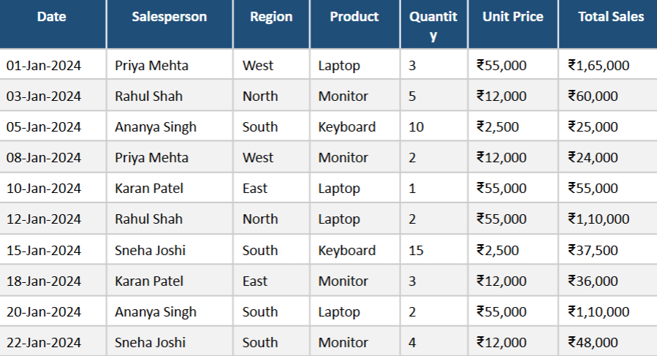

Creating your 1st Pivot table- Step by step
We’ll be using above sales data
Step- 1: Select your data
Click on any cell inside your data. Excel is intelligent — it will automatically detect the boundaries of your data. However, as a best practice, you can also manually select the entire range including headers.
Step 2 - Insert the Pivot Table
Go to the Insert tab on the Excel ribbon, then click PivotTable.
The Create PivotTable dialog box will appear. This dialog has two key settings:
- Select a table or range - Excel will have already filled this in based on your selected cell. Verify it shows the correct range (for example, Sheet1!$A$1:$G$121).
- Choose where to place the Pivot Table - Select New Worksheet (recommended). Excel will create a fresh sheet for your Pivot Table, keeping your source data clean and separate.
Click OK. Excel will create a new sheet with an empty Pivot Table on the left and the PivotTable Field List panel on the right.
Step 3 - Understand the Pivot Table Interface
When the Pivot Table is created, you will see the following layout:
Understanding the Four Areas
The PivotTable Field List has four drop zones at the bottom. These are the engine of every Pivot Table:
- Filters - Adds a dropdown above the table to filter the entire report by one field.
- Columns - Places field values as column headers running left to right.
- Rows - Places field values as row labels running top to bottom.
- Values- The field you want to calculate (sum, count, average, etc.).
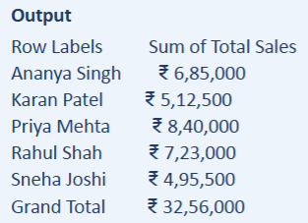
You build a Pivot Table by dragging field names from the top list into these four zones.
Step 4- Build the Pivot Table
We want to see total sales per salesperson. Follow these drag-and-drop steps:
- Drag Salesperson to the row area
- Drag Total sales to the Value area
That's all your Pivot Table is now complete

Pro tip
If your Pivot Table shows Count of Total Sales instead of Sum of Total Sales, it means Excel detected that your Total Sales column contains text values, not numbers. Fix this by:
• Selecting the entire Total Sales column in the source data.
• Going to Data → Text to Columns → Finish.
• Refreshing the Pivot Table by right-clicking it and selecting Refresh.

Topic 2: Pivot Table Fields and Layout
The PivotTable Field List (also called the Field Pane) is the control centre of every Pivot Table. Understanding every part of it will give you full control over your reports.
Part of the Field List | What it Does
Field Section (top) | Lists all column headers from your source data as draggable fields. Ticking a checkbox adds the field to the default area automatically.
Filters Area | Creates a report filter above the Pivot Table. Useful for filtering by year, department, or region without changing the table structure.
Columns Area | Values of this field become column headers. Best used for fields with a small number of values (e.g., Quarters: Q1, Q2, Q3, Q4).
Rows Area | Values of this field become row labels. Best used for fields with many categories (e.g., Product names, Salesperson names).
Values Area | The field to summarise. Excel defaults to Sum for numbers and Count for text. You can change this to Average, Max, Min, etc.

2.2 Rearranging and Removing Fields
You are never locked into one layout. Fields can be moved, rearranged, or removed at any time without affecting your source data.
Moving a Field Between Areas
To move a field from one area to another, simply drag it from its current area and drop it into the new area. For example, to move Region from Rows to Columns:
- Click and hold Region in the Rows area of the Field List.
- Drag it up and drop it into the Columns area.
The Pivot Table instantly reorganises to show Region values as column headers.
Removing a Field
To remove a field from the Pivot Table, you have two options:
- Drag the field out of its current area and drop it anywhere outside the four zones — it disappears from the table.
- Right-click the field in the area zone and choose Remove Field.

2.3 Pivot Table Layout Formats
Excel offers three different layout formats for how row labels are displayed. These can be found under the Design tab → Report Layout.
Compact Form (Default)
All row fields are stacked in a single column. This is the default and saves horizontal space. Best for most standard reports.
Outline Form
Each row field gets its own separate column. A subtotal row appears after each group. Easier to read when you have multiple row fields.
Tabular Form
Looks like a traditional data table. Each row field has its own column, and headers appear at the top of each column - ideal for copying data to another location or for printing.
Pro Tip - Which Layout Should You Use?
• Use Compact Form for quick internal analysis and dashboards.
• Use Outline Form when you have 3 or more row fields and need to see hierarchy clearly.
• Use Tabular Form when you need to export or print the Pivot Table as a formal report.

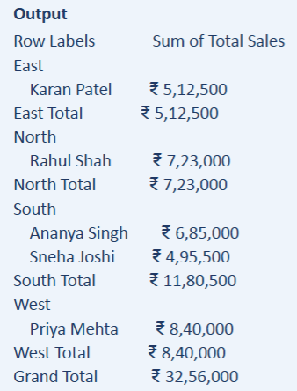
2.4 Adding Multiple Fields — Nested Layout
You can add more than one field to any area. This creates a nested hierarchy, allowing you to analyse data at multiple levels simultaneously.
Example: You want to see Total Sales broken down by Region, and within each region, by Salesperson.
- Drag Region to the Rows area.
- Drag Salesperson to the Rows area - below Region.
- Drag Total Sales to the Values area.

Topic 3: Grouping Data (Dates & Numbers)
One of the most powerful capabilities of a Pivot Table is its ability to automatically group data — particularly dates and numbers - into meaningful categories. Instead of seeing a separate row for every single date in your dataset, you can group them by Month, Quarter, or Year with a single click.
3.1 Why Group Data?
Without grouping, a Pivot Table with a Date field would show every individual date as a separate row. If your dataset covers 12 months, you might see 365 rows - which is impossible to read or interpret.
Grouping solves this problem by collapsing related values into a single, manageable category.
Without Grouping | With Grouping by month
01-Jan-2024 ₹1,65,000 | January 12,40,000
03-Jan-2024 ₹60,000 | February 9,85,000
05-Jan-2024*25,000 | March 11,20,000
... (365 rows) | ...(12 rows)

3.2 Grouping Dates
Excel can automatically group date fields by Day, Month, Quarter, Year, or any combination of these.
How to Group a Date Field - Step by Step
6. Create a Pivot Table with Date in the Rows area and Total Sales in the Values area.
7. You will see individual dates listed as row labels.
8. Right-click on any date in the Pivot Table.
9. Click Group from the context menu.
10. The Grouping dialog box appears. Select Months and Years.
11. Click OK.

Grouping Options Available for Dates
When the Grouping dialog opens, you can select one or more of the following:
- Seconds/Minutes / Hours - for time-based data
- Days- shows each individual day
- Months-groups all Jan dates together, all Feb dates, etc.
- Quarters-Q1 (Jan—Mar), Q2 (Apr-Jun), Q3 (Jul–Sep), Q4 (Oct-Dec)
- Years- groups all 2023 dates together, all 2024 dates, etc.

You can select multiple options at once — e.g., Months + Years gives you a two-level hierarchy.
3.3 Grouping Numbers
Number grouping is equally useful. If your data has a numeric field like Age, Salary, or Order Value, you can group the values into ranges — called bins — rather than listing every individual number.
Example: Group customers by age range — Under 25, 26–35, 36-45, 46 and above.
How to Group a Number Field - Step by Step
- Create a Pivot Table with Total Sales in the Rows area and a Count field in Values.
- Right-click on any value in the Rows area.
- Click Group.
- In the Grouping dialog, set the Starting at value (e.g., 0), the Ending at value (e.g., 1,00,000), and the By value the size of each group (e.g., 25,000).
- Click OK.

Pro Tip - Ungrouping Data
To remove grouping and return to the original individual values:
- Right-click any grouped label in the Pivot Table.
- Select ungroup from the context menu
The pivot Table will revert to showing individual dates or numbers
Topic 4: Pivot Chart
Numbers in a table are useful, but a chart can communicate the same information far more powerfully - especially in presentations and reports. A Pivot Chart is a visual representation of a Pivot Table that updates automatically whenever the Pivot Table data or filters change.
4.1 What is a Pivot Chart?
A Pivot Chart is a chart that is linked directly to a Pivot Table. When you change the Pivot Table — by adding a filter, changing a field, or refreshing data - the chart updates automatically to reflect those changes.
This is what makes Pivot Charts different from regular Excel charts. A regular chart is a static image based on a fixed data range. A Pivot Chart is dynamic — it responds to your Pivot Table settings in real time.
CLOUD & AI ACADEMY
4.2 Creating a Pivot Chart
Method 1 - Create a Chart from an Existing Pivot Table
- Click anywhere inside your existing Pivot Table.
- Go to the Insert tab on the ribbon.
- Click PivotChart.
- The Insert Chart dialog opens. Select your preferred chart type (for example, Clustered Bar or Line chart).
- Click OK. The chart appears on the same sheet as your Pivot Table.

Method 2 - Create a Pivot Table and Chart Together
You can create both the Pivot Table and Pivot Chart in one step using the Recommended Charts option:
- Select your data range.
- Go to Insert → PivotChart → PivotChart & PivotTable.
- Excel creates a new sheet with both the Pivot Table and an empty Pivot Chart side by side.
4.3 Interacting with a Pivot Chart
Pivot Charts have a special feature that regular charts do not — interactive field buttons. These small dropdown buttons appear directly on the chart and allow you to filter the chart without going back to the Pivot Table.
Changing the Chart Type
You can change a Pivot Chart to any chart type at any time:
- Right-click on the chart area.
- Select Change Chart Type.
- Choose a new type from the dialog (Column, Line, Pie, Bar, Area, etc.).
- Click OK.

Best Chart Types for Pivot Charts
- Bar / Column Chart - Best for comparing totals across categories (e.g., Sales by Region).
- Line Chart - Best for showing trends over time (e.g., Monthly Revenue).
- Pie Chart- Best for showing parts of a whole (e.g., % Share by Product).
- Stacked Bar Chart- Best for comparing totals while showing internal composition.
Avoid 3D charts-They distort proportions and are harder to read accurately

Topic 5: Slicer and Timelines
Slicers and Timelines are visual filtering tools that make Pivot Tables interactive and user-friendly. Instead of using dropdown filters buried inside the table, Slicers display large, clickable buttons - one for each category that filter the Pivot Table instantly when clicked.
What is a Slicer?
A Slicer is a visual filter panel — a floating box containing clickable buttons, one for each unique value in a field. Clicking a button instantly filters the Pivot Table to show only data matching that selection.
Slicers are especially useful when creating interactive dashboards, because they make filtering obvious and accessible to users who may not be familiar with the Pivot Table interface.

Analogy -The Slicer as a TV Remote
Think of a Slicer like a TV remote for your Pivot Table.
Without a remote, you would need to reach up to the TV and manually change the channel.
With a remote, you just press a button — and the screen changes instantly.
A Slicer works the same way. Without it, you right-click, filter, type values.
With it, you just click a button — and the Pivot Table updates immediately.

5.2 Inserting a Slicer
- Click anywhere inside your Pivot Table.
- Go to the PivotTable Analyze tab (this tab only appears when a Pivot Table is selected).
- Click Insert Slicer.
- A dialog box appears listing all available fields. Tick the checkbox next to the field(s) you want slicers for -for example, Region and Product.
- Click OK. One slicer panel appears for each selected field.
Using Multiple Slicers
You can have multiple slicers active at the same time. The Pivot Table will apply all active filters together. For example:
- Clicking West in the Region slicer filters the table to show only West region data.
- Then clicking Laptop in the Product slicer further filters to show only Laptop sales from the West region.
- The Pivot Table now shows only the specific slice of data you selected — which is exactly what gives Slicers their name.

Clearing a Slicer Filter
To remove a slicer filter, click the Clear Filter button at the top-right corner of the slicer panel (it looks like a funnel with a red X). This deselects all buttons and shows all data again.

What is timeline?
A Timeline is a date-specific visual filter — a horizontal bar showing months, quarters, or years that allows you to filter a Pivot Table by a time period simply by clicking and dragging over the desired range.
Timelines are only available for fields that contain proper Excel date values — not text-based dates.
5.4 Inserting a Timeline
- Click inside your Pivot Table.
- Go to PivotTable Analyze →→ Insert Timeline.
- A dialog lists your date fields - select Date and click OK.
You can use the dropdown at the top-right of the Timeline to switch between filtering by Months, Quarters, or Years.
Connecting One Slicer to Multiple Pivot Tables
A single Slicer can control multiple Pivot Tables on the same workbook — a powerful feature for dashboards.
How to connect:
- Right-click the Slicer.
- Click Report Connections (or PivotTable Connections).
- A dialog appears listing all Pivot Tables in the workbook.
- Tick the ones you want this Slicer to control.
- Click OK.
Now when you click a Slicer button, all connected Pivot Tables filter simultaneously.
Topic 6: Calculated Fields
A Calculated Field allows you to add a brand-new column to your Pivot Table by writing a custom formula - using fields that already exist in the Pivot Table. This is one of the most advanced and useful features of Pivot Tables, because it lets you create metrics that are not in your original data.
6.1 What is a Calculated Field?
A Calculated Field is a virtual column created by writing a formula using existing Pivot Table field names. It performs a calculation and adds the result as a new column in the Values area — without changing the original source data.
The critical difference between a Calculated Field and a regular Excel formula:

Regular Excel Formula | Calculated Field
Written in a cell next to the Pivot Table | Added inside the Pivot Table as a virtual field
Gets removed if the Pivot Table is moved or resized | Stays part of the Pivot Table permanently
Uses cell references (e.g., =B2*0.18) | Uses field names (e.g., =Total Sales * 0.18)
Does not update with Pivot Table filters | Updates automatically with every filter change

6.2 Creating a Calculated Field
Scenario: You want to calculate the GST Amount (18% of Total Sales) for every row in your Pivot Table.
- Click inside the Pivot Table.
- Go to PivotTable Analyze → Fields, Items & Sets → Calculated Field.
- The Insert Calculated Field dialog opens.
- In the Name field, type: GST Amount
- In the Formula field, type: = 'Total Sales' * 0.18
Note: To insert a field name into the formula, double-click it from the Fields list at the bottom of the dialog. This ensures the field name is spelled correctly.
- Click Add, then click OK.
The GST Amount column now appears in the Pivot Table automatically.
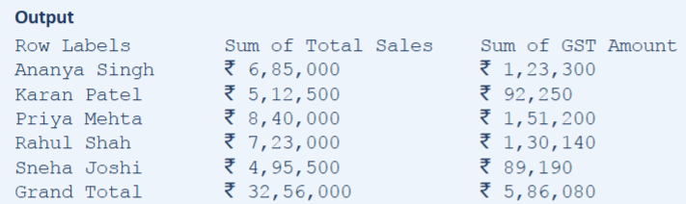

6.3 More Calculated Filed Examples
Here are additional practice examples to demonstrate the versatility of Calculated Fileds:

Example 1- Profit Margin Percentage
Scenario: You have Cost and Revenue Fileds,and you want to calculate Profit Margin as a percentage
Name: Profit Margn%
Formula= (Revenue- Cost)/Revenue*100

Example 2- Revenue After Discount
Scenario: A 10% discount is applied to all orders.Calculate the Net Revenue.
Name: Net Revenue
Formula= 'Total Sales' * 0.90

Example 3-Sales Target Achievement
Scenario: Each salesperson has target of ₹700000.Calculate what percentage of the target each person achieved.
Name=Target Achievement%
Formula= ‘Total Sales’/700000*100

Pro Tip - Editing or Deleting a Calculated Field
To edit a Calculated Field:
- Go to PivotTable Analyze → Fields, Items & Sets → Calculated Field.
- In the Name dropdown at the top of the dialog, select the field you want to edit.
- Modify the formula and click Modify.

To delete a Calculated Field:
Follow the same steps, select the field, and click Delete.

Topic 7: Basic Data analysis Tools
Excel provides two powerful analysis tools that go beyond Pivot Tables: What-If Analysis and Goal Seek. These tools help you answer forward-looking questions — not just summarising what happened in the past, but exploring what could happen under different conditions.
7.1 Introduction to What-If Analysis
What-If Analysis is a set of Excel tools that allow you to test different input values and see how those changes affect the result of a formula. It answers the question: "What would happen if this value changed?'
Excel includes three What-If Analysis tools, each suited to a different type of question:

Tool | Best Used When... | Example Question
Scenario Manager | You want to compare multiple complete sets of inputs side by side | How does profitability change in Best Case, Base Case, and Worst Case scenarios?
Data Table | You want to see how changing one or two variables affects an outcome across a range of values | How does my EMI change as the interest rate goes from 7% to 14%?
Goal Seek | You know the result you want and need to find the input that achieves it | What sales volume do I need to break even?

7.2 Scenario Manager
The Scenario Manager lets you save multiple version of your model-Each with different input values-and switch between them or generate a summary report instantly.
Example Scenario: A company is evaluating 3 possible outcomes for the next financial quarter.

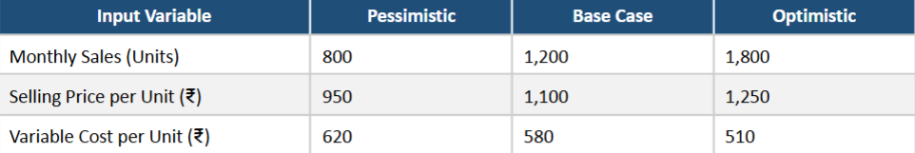
How to Create Scenarios - Step by Step
- Set up a simple model in Excel. For example, create cells for Units Sold, Price, Variable Cost, and Profit.
- Go to Data tab ← What-If Analysis → Scenario Manager.
- Click Add to create a new scenario.
- Name the scenario - for example, Base Case.
- In the Changing Cells field, select cells B1, B2, and B3 (the input cells that will change between scenarios).
- Click OK. A dialog asks for the values for each cell. Enter 1200, 1100, and 580. Click OK.
- Repeat Steps 3-6 for Pessimistic (800, 950, 620) and Optimistic (1800, 1250, 510).

Generating a Scenario Summary Report
Once all scenarios are defined, you can generate an automatic summary report:
- In the Scenario Manager dialog, click Summary.
- Select Scenario Summary as the report type.
- In the Result cells field, select B4 (the Profit cell).
- Click OK. Excel generates a new sheet with a comparison table.
7.3 Data Tables (One-Variable)
A Data Table lets you test a range of values for a single input variable and instantly see the corresponding results - all in one table. This is ideal when you want to understand sensitivity - how much does the result change when one input changes?
Example: You are calculating EMI (Equated Monthly Instalment) for a loan. You want to see how the monthly EMI changes as the annual interest rate varies from 8% to 14%.

How to Create a One-Variable Data Table
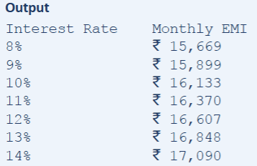
- Set up your model (Loan Amount, Interest Rate, Tenure, EMI formula).
- In Column D (D2:D8), enter the interest rate values you want to test: 8%, 9%, 10%, 11%, 12%, 13%, 14%.
- In cell E1, type =B4 (to reference the EMI formula result).
- Select the range D1:E8 (your entire table including the test values and the formula reference). 54. Go to Data tab → What-If Analysis → Data Table.
- In the Column Input Cell box, type B2 (the interest rate input cell in your model). Leave Row
- Input Cell empty.
- Click OK. Excel fills the results automatically.
7.4 Goal Seek
Goal Seek is a tool that works backwards from a desired result. You tell Excel what result you want in a specific cell, and which input cell to change — and Excel automatically finds the input value that produces that exact result.
Goal Seek answers the question: "I know the answer I want. What input do I need?"
Real-World Scenario - Break-Even Analysis
A small business owner, Neha, runs an online accessories store.
Her monthly fixed costs are ₹50,000.
She sells each product for ₹850 and the variable cost per unit is ₹350.
She wants to know: How many units must she sell each month to break even?
She does not want to guess or calculate manually.
She sets up the model in Excel and uses Goal Seek to find the answer instantly.
Setting Up the Goal Seek Model
Before using Goal Seek, always set up a proper formula-driven model in Excel:
- Running Goal Seek-Step by Step
Go to the Data tab→ What-If Analysis → Goal Seek.
- The Goal Seek dialog has three fields:
Set cell | What to Enter | In This Example
To value | The cell containing the formula you want to reach a specific value | B7 (Profit)
Field | The target result you want that formula to produce | 0 (Break-even means 0 profit)
By changing cell | The input cell Excel is allowed to modify to reach the target | B1 (Units Sold)

- Click OK. Excel runs its calculations and displays a Goal Seek Status dialog.
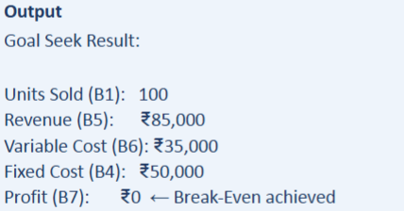
Neha now knows she must sell exactly 100 units per month to cover all her costs. Any fewer, and she makes a loss. Any more, and she makes a profit.

Pro Tip - Important Limitations of Goal Seek
- Goal Seek can only change one input cell at a time.
- The formula in the Set Cell must depend -directly or indirectly — on the By Changing Cell.
- If no solution is found, Excel will show the closest value it could reach.
- For problems with multiple changing variables, use Solver (found in Data → Solver) a more powerful tool that is an extension of Goal Seek.

Practice Exercise
This chapter presents a series of structured practice exercises designed to reinforce everything covered in this module. Each exercise includes a clear objective, the dataset to use, and step-by-step instructions for what to build.
Before You Begin
Download the Practice Dataset file from the LMS before starting these exercises.
The file is named: Pivot_Practice_Dataset.xlsx
It contains a Sales Register with 120 rows covering 6 months of transactions.
All exercises in this chapter use this same dataset unless otherwise specified.

Exercise 1- Basic Pivot Table: Sales by Product
Objective: Find the total sales revenue generated by each product category.
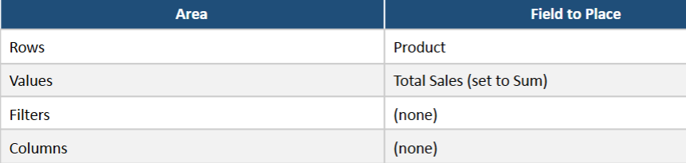
Expected Output: A Pivot Table with three rows — Keyboard, Laptop, Monitor — and the sum of Total Sales for each. A Grand Total row at the bottom.
Additional Task: Sort the Pivot Table so the highest-selling product appears at the top. Right-click any value in the Total Sales column → Sort →→ Sort Largest to Smallest.
Exercise 2 - Multi-Level Pivot Table: Region × Salesperson
Objective: Show total sales broken down first by Region, and then by Salesperson within each region.
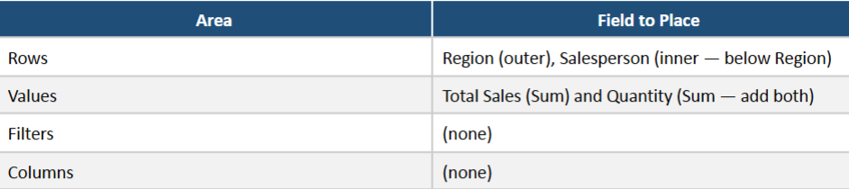
Expected Output: A nested Pivot Table showing four regions (East, North, South, West), with each salesperson listed under their respective region. Subtotals visible for each region. Grand Total at the bottom.
Exercise 3 - Date Grouping: Monthly Sales Trend
Objective: Analyse how total sales have changed month by month across the 6-month period.
Area | Field to Place
Rows | Date (then group by Month and Year after inserting)
Values | Total Sales (Sum)
Steps: After inserting the Pivot Table, right-click any date in the Rows → Group→ select Months and Years → OK.
Additional Task: Insert a Pivot Chart (Line chart) to visualise the monthly trend. The x-axis should show months and the y-axis should show total sales.

Exercise 4 - Slicer & Timeline Dashboard
Objective: Create an interactive sales summary that can be filtered dynamically.
- Create a Pivot Table showing Total Sales by Product.
- Insert two Slicers: one for Region and one for Salesperson.
- Insert one Timeline for the Date field.
- Connect both Slicers and the Timeline to the Pivot Table.
- Test: Select only 'West' in the Region Slicer and 'Q1 2024' in the Timeline. Observe how the Pivot Table updates.

Exercise 5 - Calculated Field: Profit After Commission
Objective: Add a new column to the Pivot Table that calculates the Net Sales After Commission, assuming a 5% sales commission is deducted from Total Sales.
Calculated Field Name: Net Sales After Commission
Formula: = 'Total Sales' - ('Total Sales' * 0.05)
-- which simplifies to --
= 'Total Sales' * 0.95
Expected Output: The Pivot Table should show three columns - Row Labels, Sum of Total Sales, and Sum of Net Sales After Commission for each salesperson.
Exercise 6 - Goal Seek: Target Revenue Planning
Objective: Use Goal Seek to find the number of Laptop units that must be sold to reach a revenue target of ₹10,00,000 from Laptop sales alone.
Setup instructions:
- Open a new sheet in the workbook.
- In B1, enter the current number of laptops sold: 45.
- In B2, enter the laptop price: 55000.
- In B3, enter the revenue formula: =B1*B2
- Use Goal Seek: Set B3 to 1000000 by changing B1.

Expected Output: Goal Seek should return B1 = approximately 18.18, meaning at least 19 laptops must be sold to reach or exceed the 10,00,000 target.

Exercise 7 - Scenario Manager: Budget Planning
Objective: A training company conducts workshops. Evaluate three budget scenarios for the next quarter.
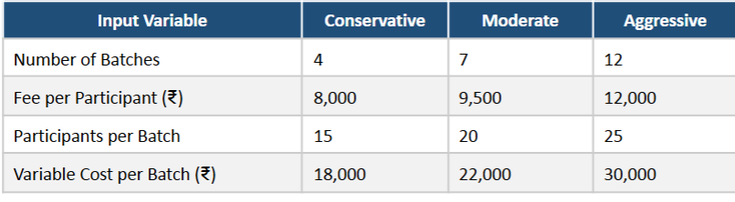
Formula to calculate: Net Revenue = (Batches × Participants × Fee) – (Batches × Variable Cost)
Task: Create all three scenarios in Scenario Manager and generate a Scenario Summary Report to compare Net Revenue across all three cases.

